
Senate Minority Whip eating at the “Little Legislators” Breakfast
House Majority Whip with her Republican napkin
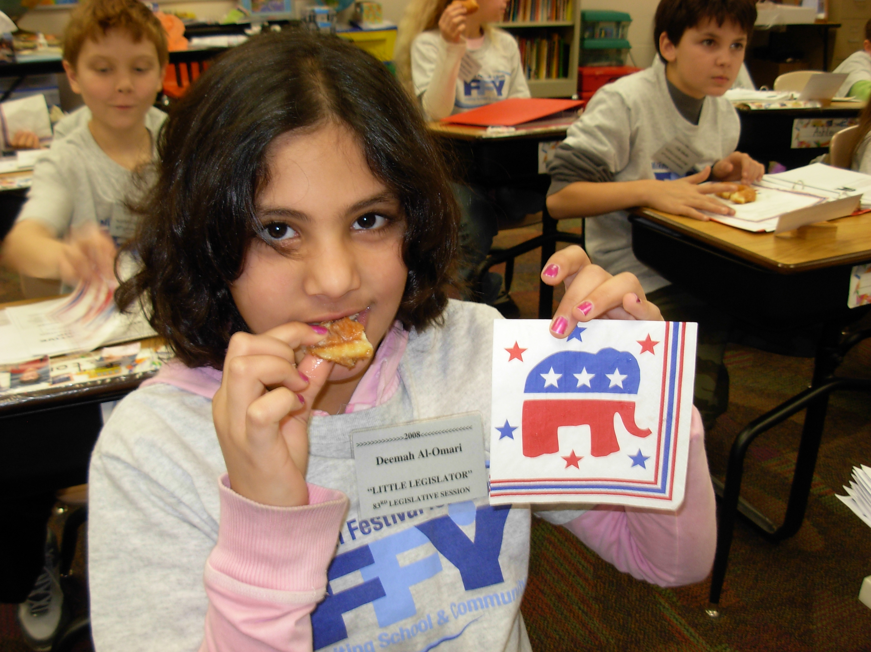
Assistant Majority Leader of the House with her Republican napkin
The President Pro Tempore at the Legislative Breakfast

