Governor Mike Rounds Signs the Rodeo Bill
Dakota Digital Network - February 27, 2003

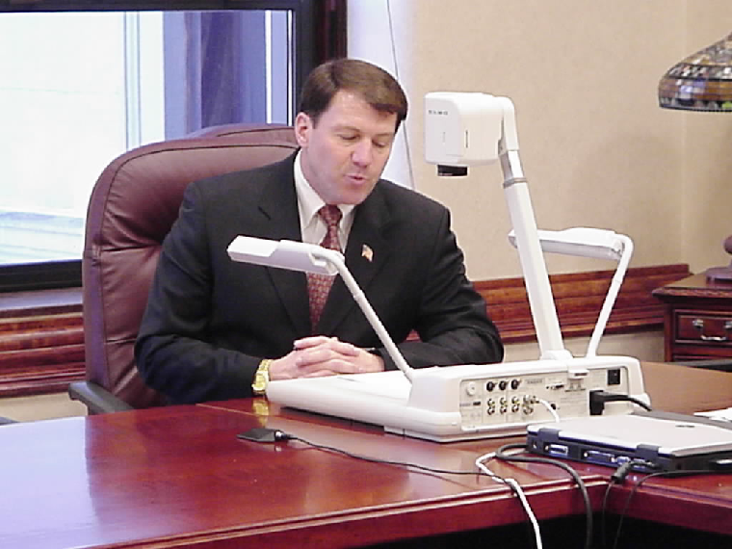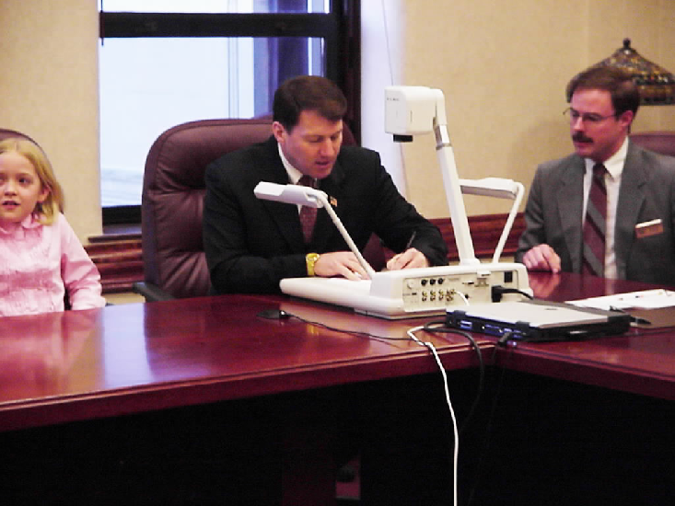
Governor Rounds shares in great detail the process involved in signing a bill. Placed on the document camera is the Rodeo Bill. Eight classrooms watched as Governor Rounds signed the rodeo bill.
Chris Nelson, Secretary of State, watches as Governor Rounds places his brand (signature) on the Rodeo Bill and makes rodeo the official South Dakota State sport. Amanda Jones (left) watches the v-tel screen as the governor signs the bill.

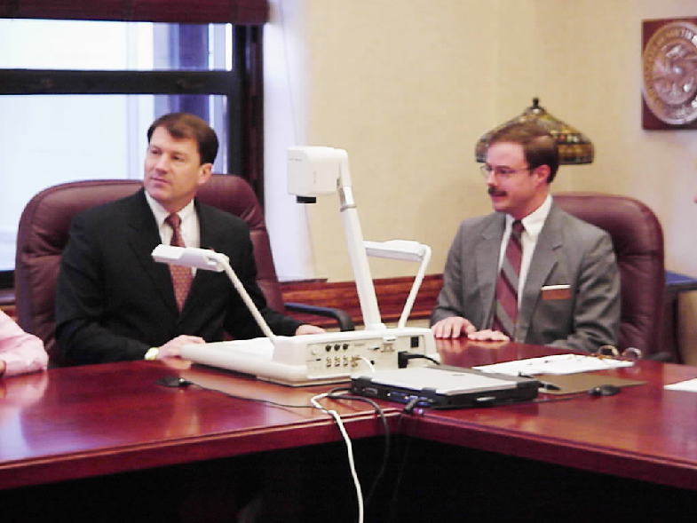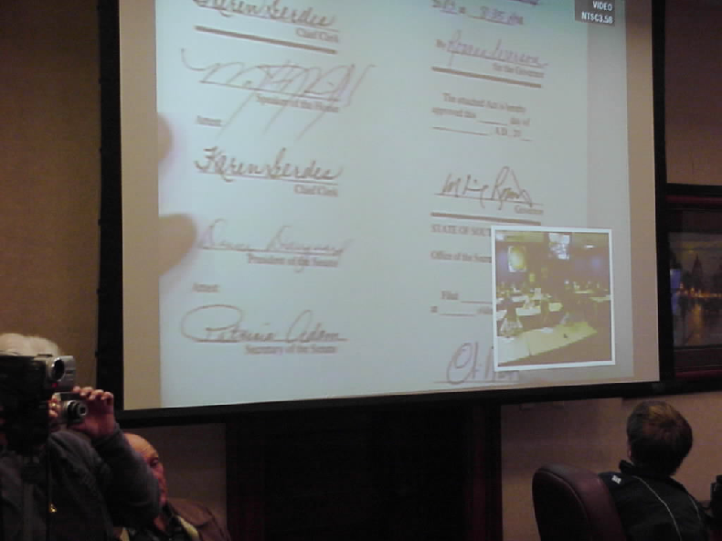
Governor Mike Rounds and Secretary of State Chris Nelson both visit with the eight schools participating in the Dakota Digital Network Legislative Project. Students listened as the “Life Cycle of a Bill” was presented. They talked with Tommy Tibbitts - the bill originator, Rep. Larry Rhoden and Sen. Eric Bogue – the Primary Sponsors, Governor Mike Rounds who signs the bill, and Secretary of State Nelson who also signs the bill and files it in his office.

