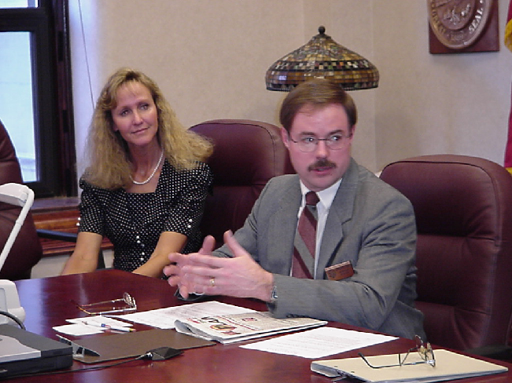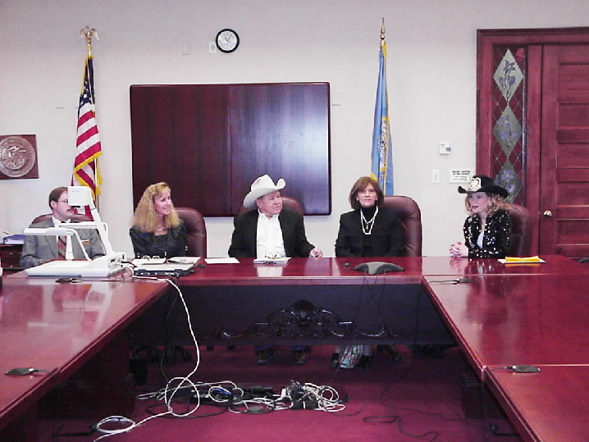

Chris Nelson, Secretary of State

Signing the Rodeo Bill
Secretary of State Chris Nelson, Marletta Eich
Tommy Tibbitts, Linda Tibbitts, Danci Anderson

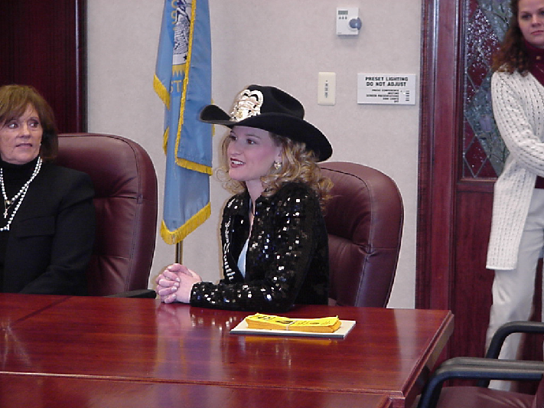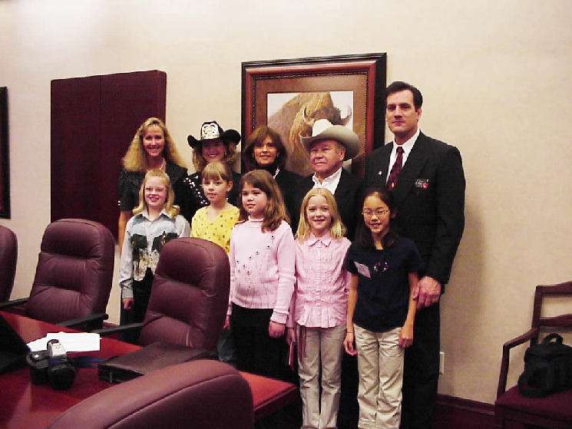

Danci Anderson
Miss Rodeo South Dakota
Marletta Eich, Danci Anderson, Linda Tibbitts, Tommy Tibbitts, Larry Rhoden
Students: Amanda Graff, Laura Froehlich, Kelsey Klosterman, Amanda Jones, Kayla Wiese

